Name | LAMANE PARTNERS (style Cleary)
Logo | LP (possible to have something similar to that of Cleary ()with these colors?)  
Color | Deep blue / blue and white (the deep blue like the one in the second picture above will replace the black in the picture below)  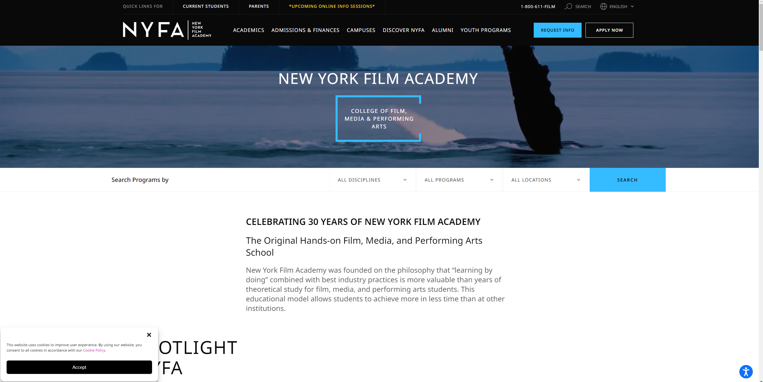
Who we are | Lamane Partners is a law firm rooted in Dakar (Senegal) with a singular focus on West African countries. The firm is dedicated to handling a wide array of African business issues, ranging from corporate/M&A and private equity to infrastructure project and finance transactions.  Lamane Partners tailors its legal strategies to meet the specific needs of its clients operating in diverse sectors. The firm is committed to building long-term relationships with clients. We prioritize understanding their business objectives and providing legal solutions aligned with their strategic goals.  With a deep appreciation for the diverse cultures and legal systems across the African continent, the firm is well-positioned to guide both local and international clients through the intricacies of West African business ventures.
Founder | Thierry embarked on his legal career in 2014 at Clifford Chance Paris where he spent 4 years. He joined Cleary Gottlieb Steen & Hamilton LLP as an associate in 2018. His exceptional talent and dedication quickly set him apart, leading to his appointment as Senior Associate in 2023 at Cleary Gottlieb Steen & Hamilton LLP.  Thierry’s practice focuses on corporate and Africa-related transactions, including mergers, acquisitions, private equity, and projects. He has advised such clients as Alstom, Atlas Trust, the historic shareholders of CGF Bourse, GlobalFoundries, Latour Capital, Loxam, the Republic of Senegal, and Sienna Investment Managers.
Practice | Expertise  Mergers & Acquisitions  Private Equity  Commercial Contracts  Corporate Governance  Infrastructure Projects  Antitrust  Funds & Investment Management  Finance | Sectors  Financial Institutions  Consumer Goods & Retail  Agribusiness  Energy & Resources  Mining  Funds & Investment Management  Healthcare, Life Sciences & Chemicals  Industrials  Real Estate  Transport & Logistics  Telecommunications, Media & Technology  Leisure and Sport
News and Insight | To come
Carreers | Same as cleary
Contact us | Same as Clifford chance (https://www.cliffordchance.com/contact.html)
Down
disclaimer | To come
Legal notice | To come

